MODIFICATION ANALYSIS DATE
REPORT

This report will be used to track loan modifications and partial claims that will require an escrow analysis during different times of the year, outside of the normal one that is run for the majority of the portfolio in late December.
Must be able to export to excel. Place in Loss Mitigation section of database.
The following information will be needed on the report:
1. Loan number
2. Last Name
3. Modified Date (if populated) – information on Loan Status Screen

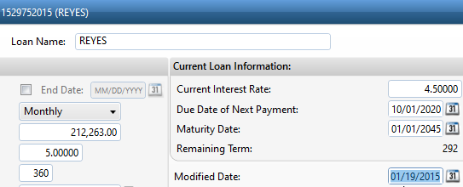

4. Loan Alert – only looking for these 3 alerts - Loan Modification, Partial Claims, or FNMA COVID Deferral

Information on Loan Details screen at bottom of page.

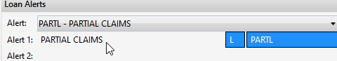

5. Modification and Loan Payment Stop Description (if populated) – General, Loan Stops, and then Modifications Stops tab. And Loan Payments Stops tab.

a) First, provide the description in Modification Stops tab

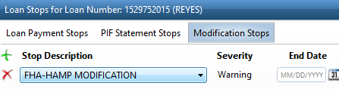

and

b) Check Loan payment stop tab to see if in Bankruptcy. If so, please provide that description also.

Look for these three descriptions.

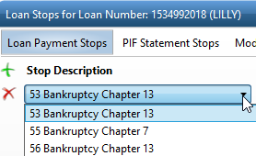

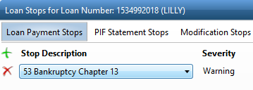

6. Next Analysis Date – General, Tax & Insurance Details, then go to Tax & Insurance Disclosure tab

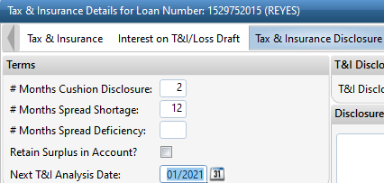

7. # Months Shortage - General, Tax & Insurance Details, then go to Tax & Insurance Disclosure tab

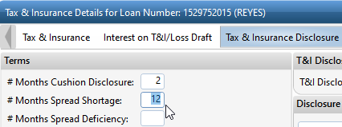

8. # Months Deficiency (if populated) - General, Tax & Insurance Details, then go to Tax & Insurance Disclosure tab.

